WEEK #4
1# A teacher wants to automate small mathematical tasks done repeatedly while checking assignments. Define separate Python functions to perform the following for the teacher:
• Compute the average of any five marks obtained by a student.
• Convert a given temperature from Celsius to Fahrenheit for recording lab conditions.
• Calculate the perimeter of a rectangular notice board kept in the classroom using its length and width.
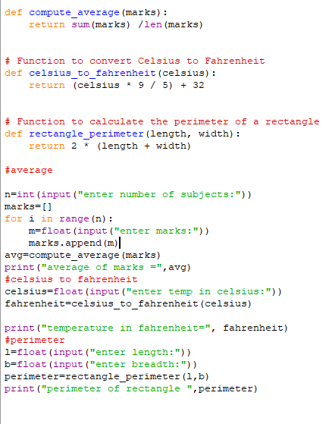
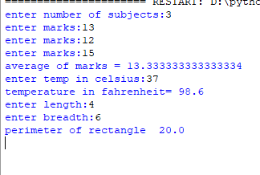
2# A science lab technician is calculating the volume of spherical containers used for experiments. Write a Python function that accepts the radius and returns the volume of the sphere.
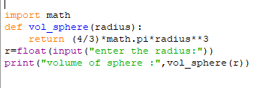
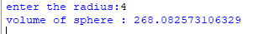
3# A landscaping company maintains circular flower beds, each with an outer radius R and an inner unused radius r. The effective area used for fertilizer is Effective Area
Write a Python function that takes R and r from the user, validates that R > r, and returns the effective usable area.
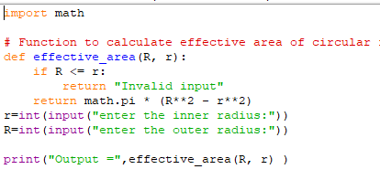
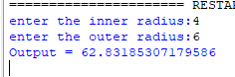
4# A data analyst needs factorial values to compute permutations. Write a Python function to calculate the factorial of a non-negative integer.
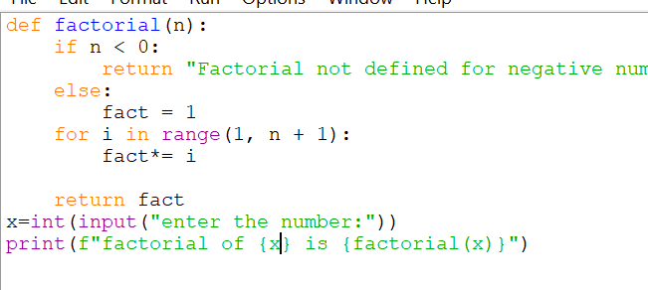
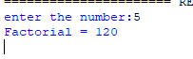
5# An accountant wants a utility that extracts a digit-sum check value from transaction IDs. Write a Python function that returns the sum of digits of a given integer.
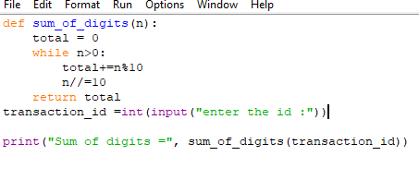
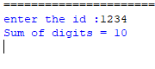
6# A math research assistant is verifying test values for numerical experiments. Write a Python function to check whether a number is a perfect number. In number theory, a perfect number is a positive integer that is equal to the sum of its proper positive divisors, that is, the sum of its positive divisors excluding the number itself. Example:6, 28 etc.
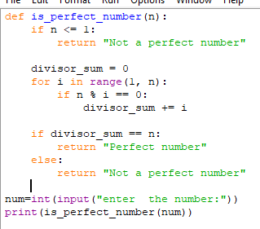
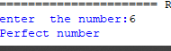

7# Write a Python function to check whether a given number is a prime number or not.
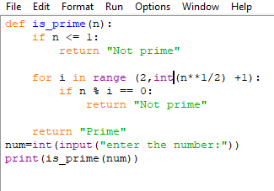
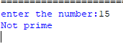
8# A text-analysis tool needs statistics from a sentence. Write a Python function that accepts a string and counts the number of uppercase and lowercase letters using isupper(), islower(), upper(), lower().
